Financial Report 2019  3D fracture behaviour monitoring presented online in real time using Spinterference | Abstract  3D fracture behaviour monitoring has been established across a rock discontinuity in the British Cave Monitoring Centre at Poole’s Cavern thanks to financial support from the British Cave Research Association. In this report the activities undertaken during the course of the project and the results obtained during the course of the project are summarised while the financial costs incurred during the course of the project are detailed. A final project report will be submitted in 2020.  Matt Rowberry  Department of Engineering Geology, Institute of Rock Structure & Mechanics, Czech Academy of Sciences, V Holešovičkách 41, 182 09 Prague 8, Czech Republic

3D fracture behaviour monitoring presented online in real time using Spinterference

Matt Rowberry¹, Ivo Baroň¹, Xavi Martí², Carlos Frontera³

¹ Department of Engineering Geology, Institute of Rock Structure & Mechanics, v.v.i, Czech Academy of Sciences, V Holešovičkách 41, 182 09 Prague 8, Czech Republic.
² Department of Spintronics & Nanoelectronics, Institute of Physics, Czech Academy of Sciences, v.v.i., Cukrovarnická 10, 162 00 Prague 6, Czech Republic.
³ Department of Magnetic Materials & Functional Oxides, Institut de Ciència de Materials de Barcelona, ICMAB-CSIC, Campus UAB, E-08193 Bellaterra, Barcelona, Spain.

Table of contents
Key points 1
Summary of activities 2
Summary of results 2
Financial expenditure 4
Appendix I: Scientific research at Poole’s Cavern 5
Appendix II: Itemised statement 6

Key points
- The Cave Science & Technology Research Fund provided 12 months of financial support for the project “3D fracture behaviour monitoring presented online in real time using Spinterference”.
- During the course of this project one Spinterference contactless positioning system was fabricated by IGS Research and installed in the British Cave Monitoring Centre at Poole’s Cavern.
- Magnetic field data are streamed to a computing cluster, transformed into three dimensional displacement data, and presented online in real time. These data are available for download.
- The deliverable outcomes include one social media post and one conference presentation as well as one manuscript which will be submitted during the first half of 2020.
- The CSTRF and the BCMC provided 3 000 GBP for the project while its final cost came to 3 008.85 GBP. This expenditure is described and an itemised statement is presented.

Summary of activities
From January to March 2019, one Spinterference contactless positioning system was fabricated by IGS Research in Tarragona while a control unit for the contactless positioning system was fabricated at the Institute of Rock Structure & Mechanics ASCR. During this period an exhaustive search of the published literature was made in order to compile a database of all the archaeological and scientific research undertaken at Poole’s Cavern. This database has been used as the basis of a comprehensive literature review - which will be included in the final project report - while the references are presented in Appendix I. In March 2019, Matt Rowberry and Ivo Baroň travelled to Poole’s Cavern to record structural geological measurements inside the cave and to select a suitable monitoring point for the contactless positioning system. From April to June 2019, the contactless positioning system and its control unit were tested together in Prague while fast execution algorithms for transforming magnetic field data into three dimensional displacement data were prepared by Carlos Frontera at the Institute of Materials Science of Barcelona. In June 2019, Matt Rowberry and Xavi Martí travelled to Poole’s Cavern to install the contactless positioning system across a conspicuous mechanical discontinuity in an otherwise coherent rock block in the Main Chamber (Figure 1). Ethernet cable had to be laid in the cave to connect the monitoring point to the hut at the cave entrance while mains electricity supplies energy to the contactless positioning system and its control unit. From July 2019 to January 2020, the magnetic field data from Poole’s Cavern have been transmitted to a computing cluster at the Institute of Physics ASCR. These data are immediately transformed into three dimensional displacement data and plotted online in real time. Furthermore, the three dimensional displacement data are available for download as txt files from: https://aspinai.eu/fzu/geo/uk1/. In October 2019, Matt Rowberry presented an outline of the project at the Cave Science Symposium, held at the British Geological Survey near Nottingham. In December 2019, he began to explore and analyse all the data from Poole’s Cavern - including those time series recorded by the Tinytag Loggers - with the aim of recognising meaningful patterns and trends. Unfortunately, significant relationships are yet to be identified but a second attempt will be made in the first quarter of 2020.

Summary of results
The fracture behaviour monitoring data obtained from Poole’s Cavern are plotted online in real time as well as being available for download as txt files from: https://aspinai.eu/fzu/geo/uk1/. Until now the project has delivered one social media post on the facebook page of the British Cave Research Association and one conference presentation at the Cave Science Symposium while one manuscript - representing the final project report - is in preparation for Cave & Karst Science:
Gunn, J., Rowberry, M., 2019. Rock stability monitoring in the British Cave Monitoring Centre at Poole’s Cavern. British Cave Research Association, Facebook, 14 August 2019.
Rowberry, M., Martí, X., Frontera, C., Baroň, I., 2019. Cave stability monitoring and its significance for environmental protection. BCRA Cave Science Symposium, 19-20 October 2019, British Geological Survey, UK.
Rowberry, M., Martí, X., Frontera, C., Baroň, I., Garcés, J., 2020. 3D fracture behaviour monitoring presented online in real time from the British Cave Monitoring Centre. In preparation for: Cave and Karst Science.
Furthermore, it is hoped that a second manuscript will result from the comparison of data from Poole’s Cavern with data obtained from a similar installation at Castañar Cave in Spain. Indeed, as the fracture behaviour monitoring at Poole’s Cavern will continue for an indefinite period, a number of additional outputs from this project are anticipated in the future.

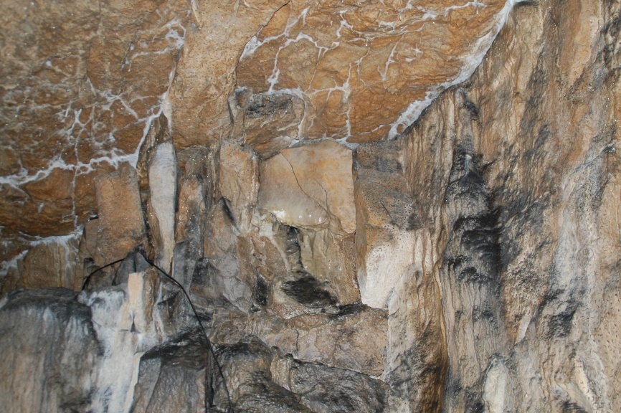
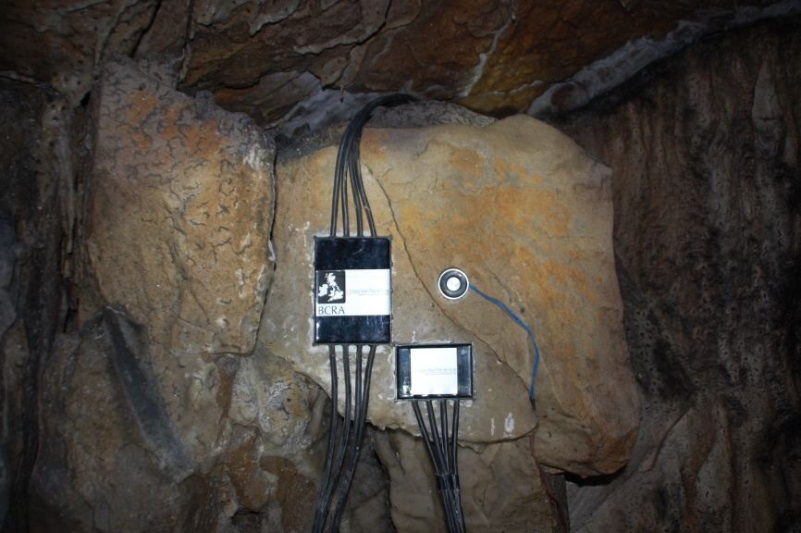
Figure 1 Installation of the Spinterference contactless positioning system across a conspicuous mechanical discontinuity in an otherwise coherent rock block in the Main Chamber.

Financial expenditure
In the original application it was estimated that the project would cost a total of 3 270 GBP while the BCRA Cave Science & Technology Research Fund and the British Cave Monitoring Centre were able to provide the applicants with a total of 3 000 GBP. To manage this funding shortfall it was decided that a small proportion of the material and travel costs could be covered by the Institute of Physics ASCR through their Horizon 2020 antiferromagnetic spintronics project ASPIN. In terms of material costs, the total amount spent came to 1 589.56 GBP, compared to the original estimate of 1 850 GBP. In detail, the total amount spent on the contactless positioning system came to 1 253.26 GBP, compared to the original estimate of 1 320 GBP, while the total amount spent on components for the control unit came to 336.30 GBP, compared to the original estimate of 530 GBP. Here savings reflect the fact that many of the cheaper components for the control unit were purchased through ASPIN. These savings were offset slightly by unforeseen costs such as non-sterling transactions fees levied by the Cooperative Bank and duties levied by the Czech authorities on items imported from Switzerland. In terms of travel expenditure, the total amount spent came to 1 419.29 GBP, compared to the original estimate of 1 420 GBP, despite the fact that three trips, rather than two, were made to the United Kingdom. The first and second trips related to fieldwork in Poole’s Cavern while the third related to outlining the project at the Cave Science Symposium on 19 October 2019. In detail, the total amount spent on flights came to 668.15 GBP, compared to the original estimate of 600 GBP, the total amount spent on subsistence came to 220 GBP, compared to the original estimate of 500 GBP, the total amount spent on accommodation came to 197.70 GBP, compared to the original estimate of 160 GBP, while the total amount spent on car hire - including fuel and insurance - and public transport came to 333.44 GBP, compared to the original estimate of 160 GBP. The opportunity for Matt Rowberry to attend the Cave Science Symposium resulted from the fact that the ASPIN project paid for Xavi Martí to fly to the UK in June 2019. Consequently the total amount spent during the course of the project came to 3 008.85 GBP. All the relevant invoices are kept at the Institute of Rock Structure & Mechanics ASCR while an itemised statement is given in Appendix II.

Appendix I: Scientific research at Poole’s Cavern
Baker, A., Jones, A., Genty, D., 1998. Extraordinarily fast stalagmite deposition in Poole’s Cavern, Buxton. Cave and Karst Science, v. 25, p. 37.
Baker, A., Proctor, C., Barnes, W., 1999a. Variations in stalagmite luminescence laminae structure at Poole's Cavern, England, AD 1910-1996. Holocene, v. 9, p. 683-688.
Baker, A., Proctor, C., Bolton, L., Barnes, W., 1999b. Historical climate records from annually laminated stalagmites in Poole’s Cavern, Buxton, Derbyshire, UK. Cave and Karst Science, v. 26, p. 41.
Blewett, P., 2019. The Tinytag Connect System and its application in the British Cave Monitoring Centre. CREG Journal, v. 108, p. 17-20.
Bramwell, D., Dalton, K., Drinkwater, J., Hassall, J., Lorimer, K., Mackreth, K., 1983. Excavations at Poole’s Cavern, Buxton. Derbyshire Archaeological Journal, v. 103, p. 47-74.
Branigan, K., Bayley, J., 1989. The Romano-British metalwork from Poole's Cavern, Buxton. Derbyshire Archaeological Journal, v. 109, p. 34-50.
Crofton, D., 1866. On vestiges of ancient human habitations in Poole’s Cavern, Derbyshire. Proceedings of the Royal Irish Academy, v. 9, p. 536-539.
Eddies, R., Walker, A., 1998. Poole’s Cavern probing. Caves and Caving, v. 80, p. 7.
Glennie, E., 1953. Hydrological tests at Poole’s Cavern, Buxton, Derbyshire. Newsletter of the Cave Research Group of Great Britain, v. 45-46, p. 5-10.
Hartland, A., Fairchild, I., Lead, J., Dominguez Villar, D., Baker, A., Gunn, J., Baalousha, M., Ju-Nam, Y., 2009. The dripwaters and speleothems of Poole's Cavern. Cave and Karst Science, v. 36, p. 37-46.
Hartland, A., Fairchild, I., Lead, J., Baker, A., 2010. Fluorescent properties of organic carbon in cave dripwaters. Science of the Total Environment, v. 408, p. 5940-5950.
Hartland, A., Fairchild, I., Lead, J., Zhang, H., Baalousha, M., 2011. Size, speciation, and lability of NOM-metal complexes in hyperalkaline cave dripwater. Geochimica et Cosmochimica Acta, v. 75, p. 7533-7551.
Hartland, A., Fairchild, I., Lead, J., Borsato, A., Baker, A., Frisia, S., Baalousha, M., 2012. From soil to cave: transport of trace metals by natural organic matter in karst dripwaters. Chemical Geology, v. 304-305, p. 68-82.
Hartland, A., Fairchild, I., Müller, W., Dominguez Villar, D., 2014. Preservation of NOM-metal complexes in a modern hyperalkaline stalagmite. Geochimica et Cosmochimica Acta, v. 128, p. 29-43.
Newton, K., Fairchild, I., Gunn, J., 2015. Rates of calcite precipitation from hyperalkaline waters, Poole's Cavern, Derbyshire, UK. Cave and Karst Science, v. 42, p. 116-124.
Pitty, A., 1966. An approach to the study of karst water illustrated by results from Poole's Cavern, Buxton. University of Hull, Occasional Papers in Geography, v. 5, p. 210-230.
Smithson, P., 1991. Interrelationships between cave and outside air temperatures. Theoretical and Applied Climatology, v. 44, p. 65-73.
Smithson, P., 1993. Vertical temperature structure in a cave environment. Geoarchaeology, v. 8, p. 229-240.
Smithson, P., Branigan, K., 1992. Poole's Cavern, Buxton - investigation of a Romano-British working environment. Derbyshire Archaeological Journal, v. 111, p. 40-45.
Watkin, W., 1887. Recent Roman discoveries in Britain. The Reliquary: Quarterly Archaeological Journal & Review, v. 1, New Series, p. 106-109.

Appendix II: Itemised statement
Date | Type | Description | Money Out
12.02.2019 | Materials | Centro de Calculo - Spinterference | £1,253.26
14.02.2019 | Travel | Eurowings - Prague to Manchester | £163.41
14.02.2019 | Travel | Eurowings - NSTF | £4.49
14.02.2019 | Travel | Austrian Airlines - Vienna to Manchester | £157.21
14.02.2019 | Travel | Green Motion - Car rental | £40.46
15.02.2019 | Materials | Yoctopuce - voltmeter | £100.28
15.02.2019 | Materials | Yoctopuce - NSTF | £2.75
04.03.2019 | Subsidence | ATM cash withdrawal | £80.00
04.03.2019 | Travel | Green Motion - Car insurance | £128.00
04.03.2019 | Travel | Green Motion - Fuel | £20.00
06.03.2019 | Subsidence | ATM cash withdrawal | £40.00
08.03.2019 | Accommodation | TSG Castleton - two people x four nights | £48.00
25.04.2019 | Travel | KLM - Prague to Manchester | £216.25
14.05.2019 | Materials | Conrad Electronic - Enclosure | £80.83
14.05.2019 | Materials | Conrad Electronic - NSTF | £2.22
07.06.2019 | Travel | Enterprise - car rental and insurance | £115.65
07.06.2019 | Travel | Enterprise - NSTF | £3.18
17.06.2019 | Accommodation | TSG Castleton - two people x four nights | £48.00
19.06.2019 | Materials | Amazon Marketplace - Ethernet cable | £119.98
24.06.2019 | Subsidence* | ATM cash withdrawal | £80.00
09.07.2019 | Materials | Voltmeter import tax from Switzerland | £30.24
09.10.2019 | Travel | Czech Airlines - Prague to Birmingham | £126.79
09.10.2019 | Accommodation | National Water Sports Centre | £101.70
21.10.2019 | Travel | West Coast Trains - Birmingham to Nottingham | £26.15
21.10.2019 | Subsidence | ATM cash withdrawal | £20.00
 |  |  | £3,008.85
* Also includes fuel
NSTF - Non Sterling Transaction Fee

